### **DCI Formats in 5G NR**

Downlink Control Information (DCI) provides the UE with the necessary information such as physical layer resource allocation, power control commands, HARQ information for both uplink and downlink.

DCI is transmitted on the Physical Downlink Control Channel (PDCCH) with 24-bit CRC attachment. In contrast, 16-bit CRC was defined for LTE. The increase in the CRC size reduces the risk of incorrect reception at the receiver end.

Multiple DCI formats are defined to meet different needs but the number of DCI formats are reduced as compared to LTE. Unlike LTE DCI formats, several of NR DCI formats can share same DCI size. The following table summarizes the DCI formats, their usage and the corresponding RNTI types.

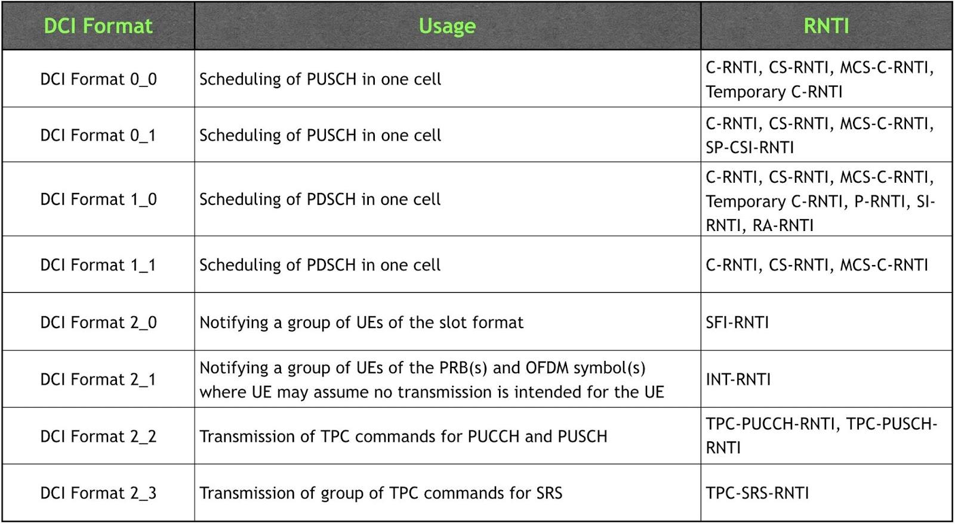

The total number of different DCI sizes configured to monitor is up to **four** for a cell and the total number of different DCI sizes with C-RNTI configured to monitor is up to **three** for a cell. Out of these three DCI sizes, one size is for scheduling downlink assignments for **non-fallback** format (DCI format 1_1), one size for **fallback** DCI formats (DCI formats 0_0 and 1_0) and the third size for uplink scheduling non-fallback format (DCI format 0_1).

Use of fallback DCI formats in general avoids uncertainties during e.g. RRC reconfiguration in which case the network doesn’t know the exact time when the UE has applied the configuration. Moreover, fallback DCI formats are usually of less size compared to non-fallback DCI formats. The size of the non-fallback DCI format varies depending on the active configuration.

**DCI Format 0_0**

DCI format 0_0 is used for uplink resource allocation (scheduling grants) for PUSCH. As explained before, this is a fallback DCI format.

The following table summarizes the information transmitted by means of the DCI format 0_0 with CRC scrambled by C-RNTI or CS- RNTI or MCS-C-RNTI or Temporary C-RNTI (TC-RNTI).

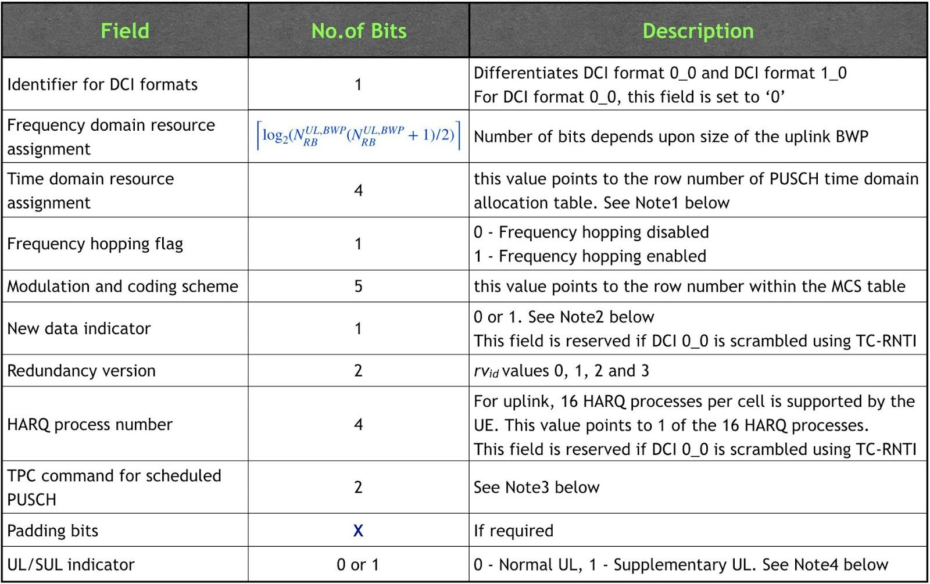

- **Note1**: Through “Time domain resource assignment” field in the DCI, the network indicates the entry to choose from PUSCH time domain allocation table. The table is either the default PUSCH time domain allocation according to table 6.1.2.1.1-2 from 38.214 or configured by RRC using IE *PUSCH-TimeDomainResourceAllocationList* within *PUSCH-Config*.

- **Note2**: If the NDI value is **toggled** as compared to previous transmission for the same HARQ process, a new transmission is triggered, else, a re-transmission is triggered. For the case of configured grant (PDCCH DCI Format 0_0/0_1 scrambled with CS-RNTI), if NDI value is set 1, a re-transmission is trigged.

- **Note3**: Transmit Power Control (TPC) command in DCI format 0_0/0_1 is used to control PUSCH transmit power. The purpose of TPC is to maintain sufficient energy-per-bit which is driven by the QoS requirement of certain service, at the same time ensuring the interference is at the acceptable level. The mapping of 2 TPC bits to actual power adjustment depends on whether “accumulation” is enabled or not. This is configured by RRC via *tpc-Accumulation* within IE *PUSCH-PowerControl* which is part of *PUSCH-Config*. The following table gives the mapping.

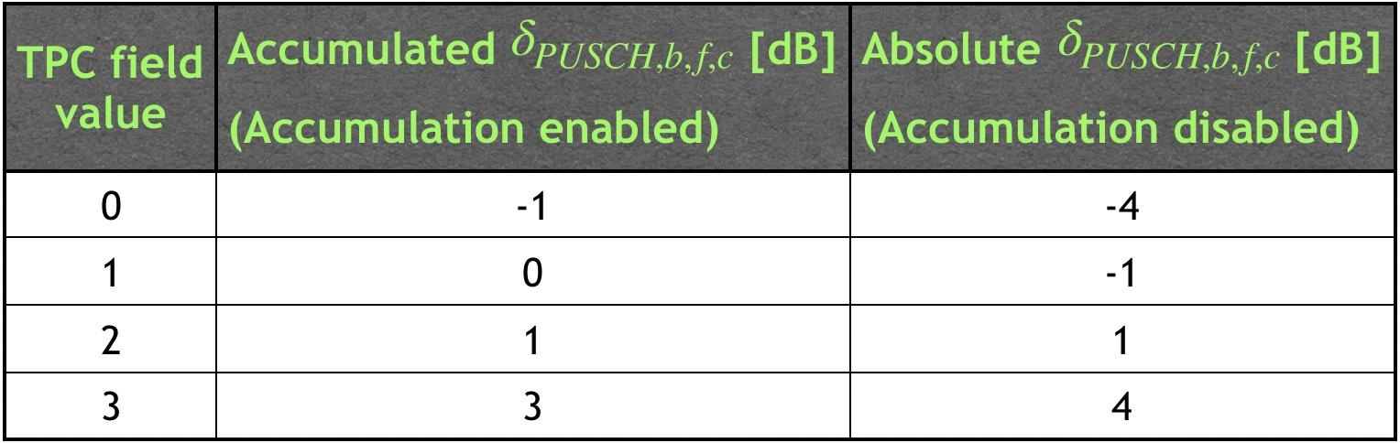

- **Note4**: UL/SUL indicator is 1 bit for UEs configured with *supplementaryUplink* and the number of bits for DCI format 1_0 before padding is larger than the number of bits for DCI format 0_0 before padding; 0 bit otherwise. If the DCI format 0_0 is scrambled with TC-CRNTI, this bit is reserved and the corresponding PUSCH is always on the same UL carrier as the previous transmission of the same TB.

**DCI Format 0_1**

DCI format 0_1 is used for uplink resource allocation (scheduling grants) for PUSCH. As explained before, this is a non-fallback DCI format. It’s CRC can be scrambled by C-RNTI or CS- RNTI or MCS-C-RNTI or SP-CSI-RNTI.

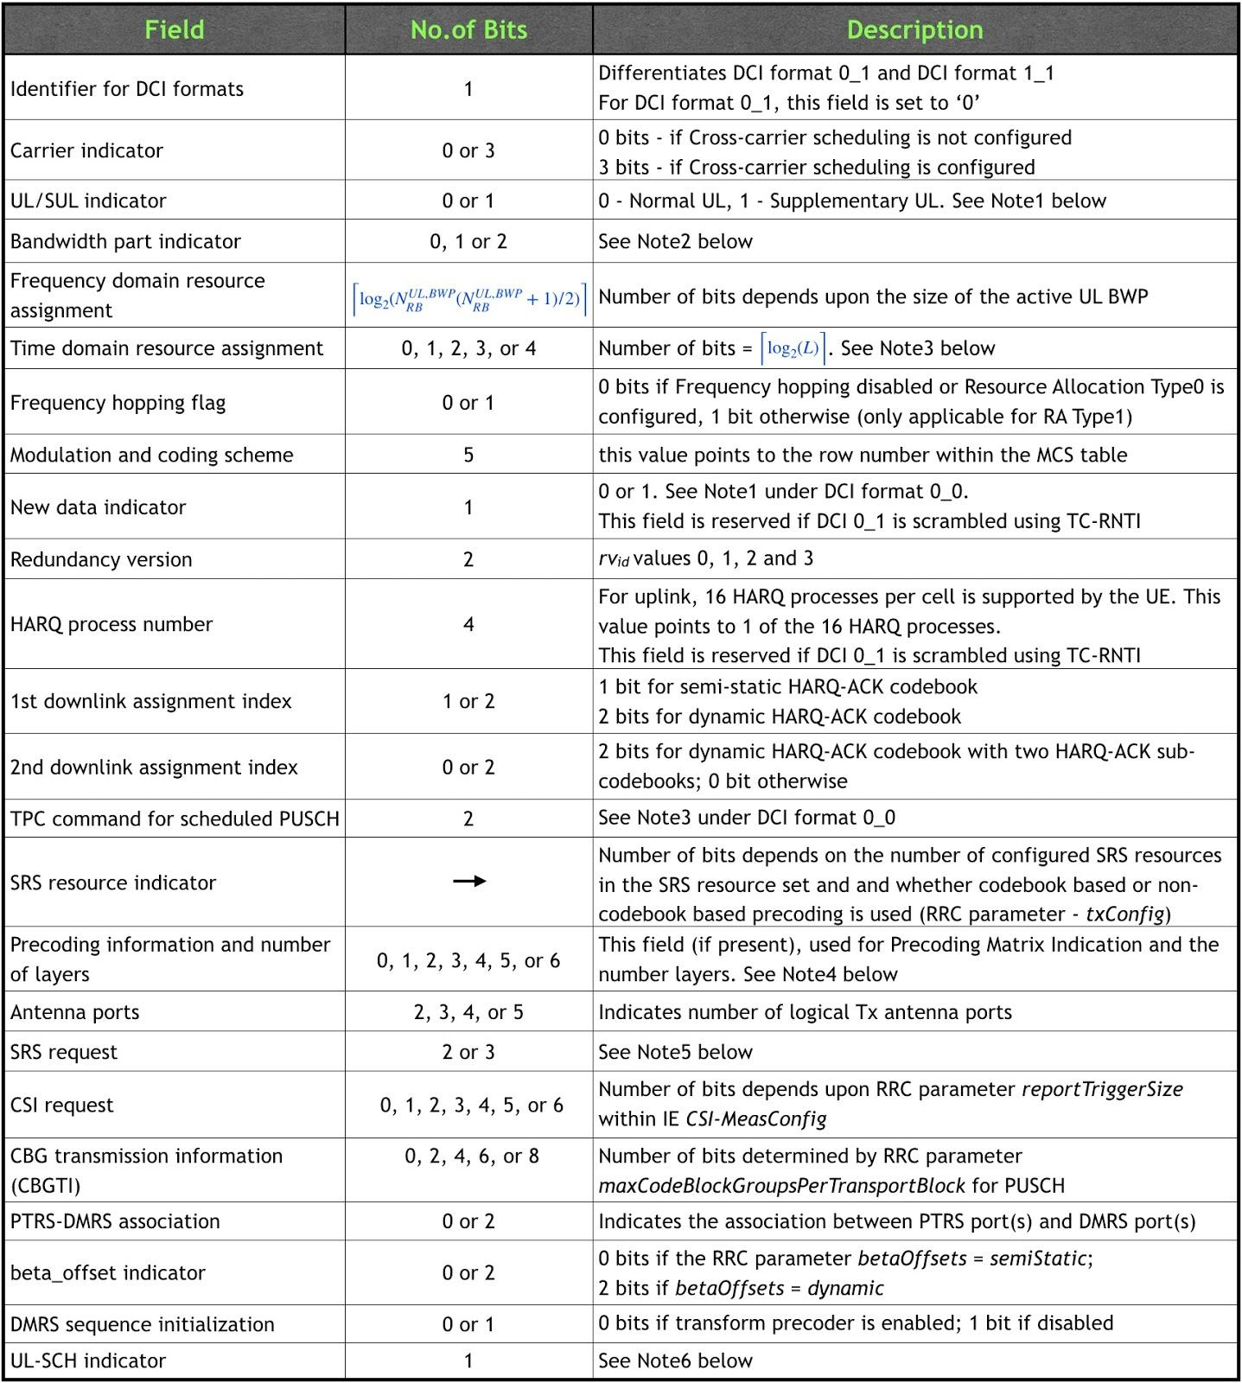

- **Note1** - UL/SUL indicator: 0 bit for UEs not configured with *supplementaryUplink* or UEs configured with *supplementaryUplink* but only carrier transmitting PUCCH in the cell is configured for PUSCH transmission; otherwise, 1 bit.

- **Note2** - Bandwidth part indicator: Indicates the BWP in which the current frequency resources (provided via this DCI) are located. This field takes 0, 1 or 2 bits depending upon the number of UL BWPs configured by RRC, excluding the initial UL BWP. If a UE does not support active BWP change via DCI, the UE ignores this bit field.

- **Note3**: Through “Time domain resource assignment” field in the DCI, the network indicates the entry to choose from PUSCH time domain allocation table. The table is either the default PUSCH time domain allocation according to table 6.1.2.1.1-2 from 38.214 or configured by RRC using IE *PUSCH-TimeDomainResourceAllocationList* which is configured in *PUSCH-Config*. The bitwidth for this field is determined as Ceiling(log base 2 (*L*)) bits, where *L* is the number of entries in the higher layer parameter *pusch-TimeDomainAllocationList* if the higher layer parameter is configured; otherwise *L* is the number of entries in the default table*.*

- **Note4** - Precoding information and number of layers: 0 bits for non-codebook based transmissions or for codebook based transmissions and single antenna port. Otherwise, if this field is present, the number of bits depends upon no. of layers and maximum RRC configured rank which is configured by *maxRank* within the IE *PUSCH-Config*.

- **Note5** – SRS request: Used for triggering aperiodic SRS resource sets. 2 bits are required for this purpose. When *supplementaryUplink* is configured, additional bit (first bit of 3 bits) is required for non-SUL or SUL indication.

- **Note6** – UL-SCH indicator: A value of "1" indicates UL-SCH shall be transmitted on the PUSCH and a value of "0" indicates UL-SCH shall not be transmitted on the PUSCH. PUSCH without UL-SCH could be useful in case if just UCI is being requested by the network using this DCI.

**DCI Format 1_0**

DCI format 1_0 is used for allocating downlink resources for PDSCH. As explained before, this is a fallback DCI format. The presence and the value of a specific field within DCI format 1_0 depends upon the type of the RNTI with which DCI format 1_0 is being scrambled with.

**DCI format 1_0 with CRC scrambled by C-RNTI/CS-RNTI/MCS-C-RNTI/TC-RNTI:**

The following table summarizes the information transmitted by means of the DCI format 1_0 with CRC scrambled by C-RNTI or CS- RNTI or MCS-C-RNTI or Temporary C-RNTI (TC-RNTI).

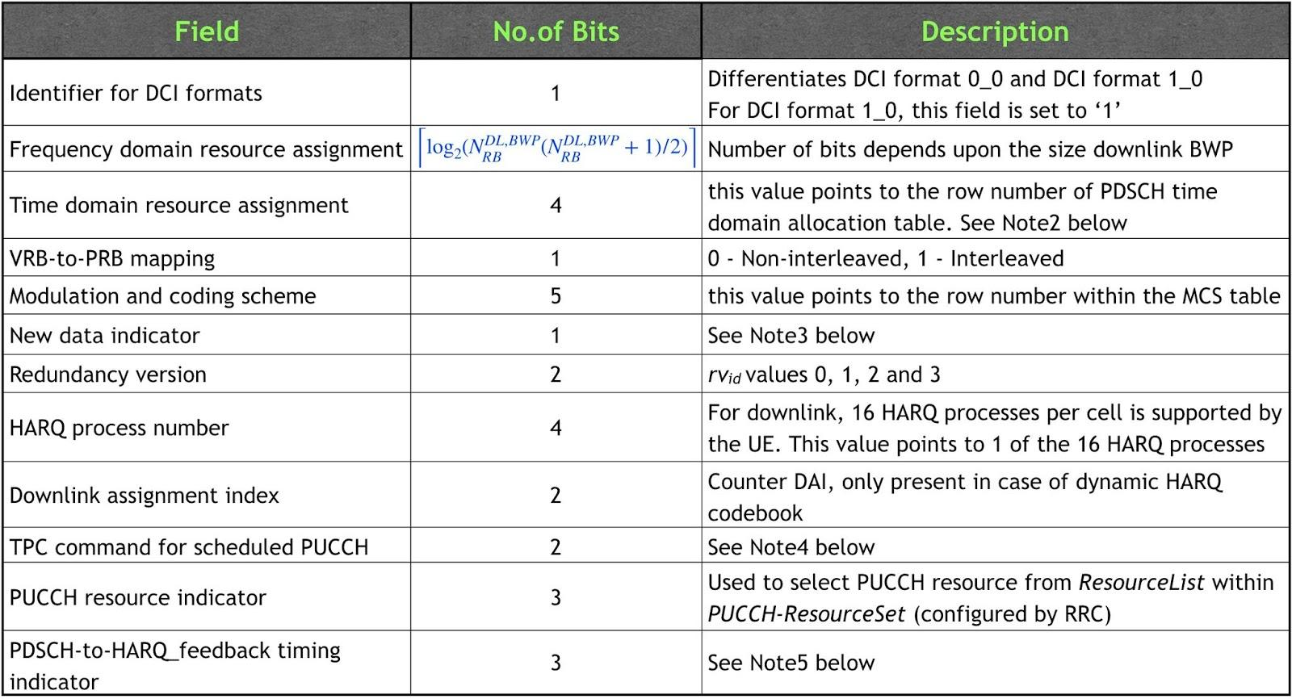

**DCI format 1_0 with CRC scrambled by C-RNTI for PDCCH order:**

PDCCH order is sent by the gNB upon DL data arrival during RRC_CONNECTED when uplink is Out-of-Sync. Upon receiving the PDCCH order, the UE triggers random access procedure. The following table summarizes the information transmitted by means of the DCI format 1_0 with CRC scrambled by C-RNTI for **PDCCH order**.

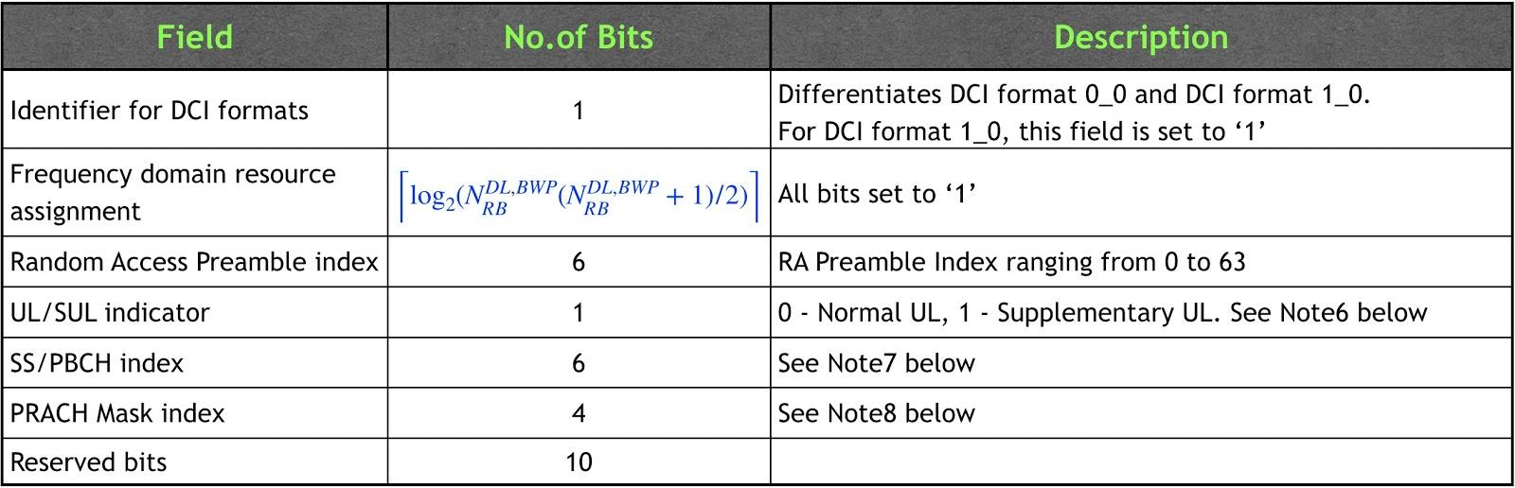

**DCI format 1_0 with CRC scrambled by P-RNTI:**

DCI format 1_0 is used for paging and notification for SI modifications/ETWS/CMAS purposes. The following table summarizes the information transmitted by means of the DCI format 1_0 with CRC scrambled by P-RNTI.

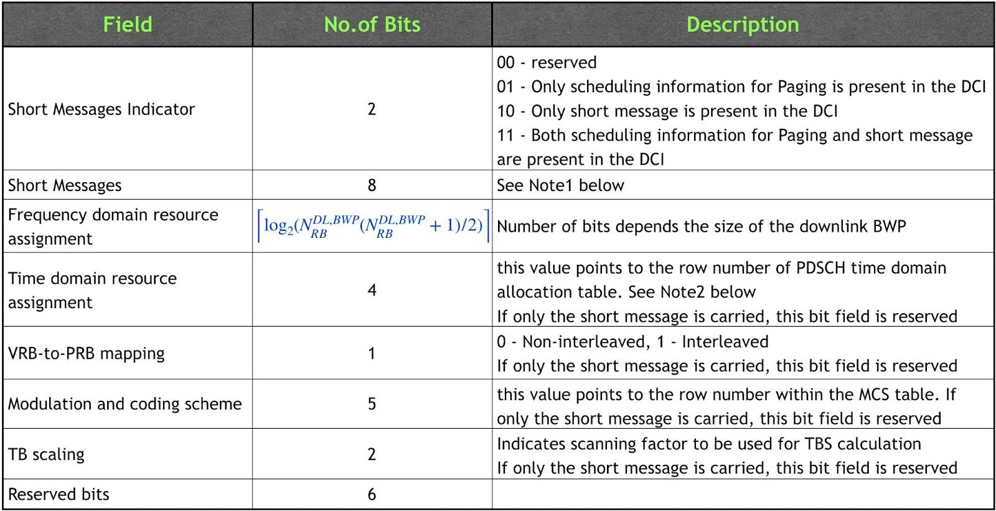

**DCI format 1_0 with CRC scrambled by SI-RNTI:**

PDCCH DCI format 1_0 scrambled with SI-RNTI is used for broadcast of System Information.

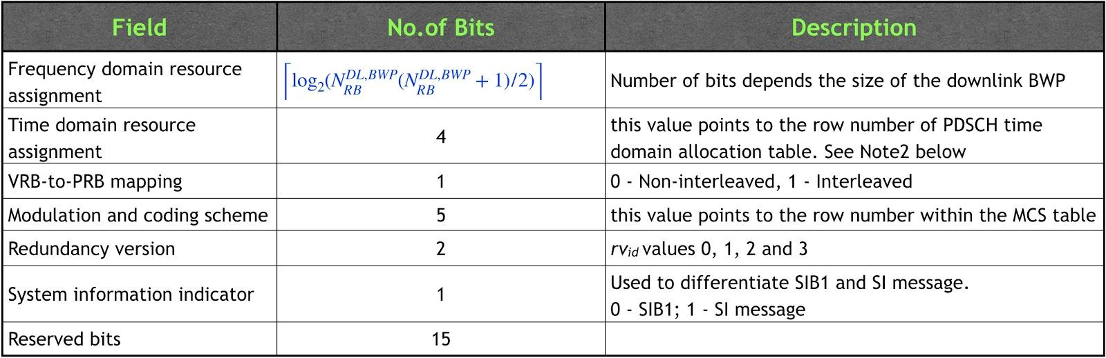

**DCI format 1_0 with CRC scrambled by RA-RNTI:**

PDCCH DCI format 1_0 scrambled with RA-RNTI is used for Random Access Response (RAR).

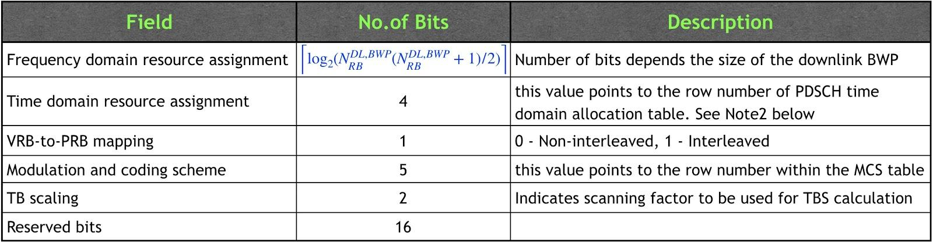

- **Note1** - Short Messages: Short Messages can be transmitted on PDCCH using P-RNTI with or without associated *Paging* message using Short Message field in DCI format 1_0. Bit-1 (MSB) if set to ‘1’, indicates System Information modification (other than SIB6, SIB7, and SIB8). Bit-2 if set to ‘1’ indicates ETWS (primary and/or secondary) notification and/or a CMAS notification. Bits 3-8 are reserved.

- **Note2**: Through “Time domain resource assignment” field in the DCI, the network indicates the entry to choose from PDSCH time domain allocation table. The table is either the default PDSCH time domain allocation according to table 5.1.2.1.1from 38.214 or configured by RRC using IE *pdsch-TimeDomainAllocationList* in either *pdsch-ConfigCommon* or *pdsch-Config*.

- **Note3** - NDI: If the NDI value is **toggled** as compared to previous transmission for the same HARQ process, a new transmission is triggered, else, a re-transmission is triggered. For the case of SPS (PDCCH DCI Format 1_0/1_1 scrambled with CS-RNTI), if NDI value is set 1, a re-transmission is trigged.

- **Note4** - TPC command for scheduled PUCCH: The gNB uses TPC command in DCI format 1_0/1_1 to provide PUCCH transmit power adjustment. The mapping of 2 TPC bits to actual power adjustment is given by the following table. Unlike PUSCH’s case, only Accumulation enabled case is supported for PUCCH’s TPC.

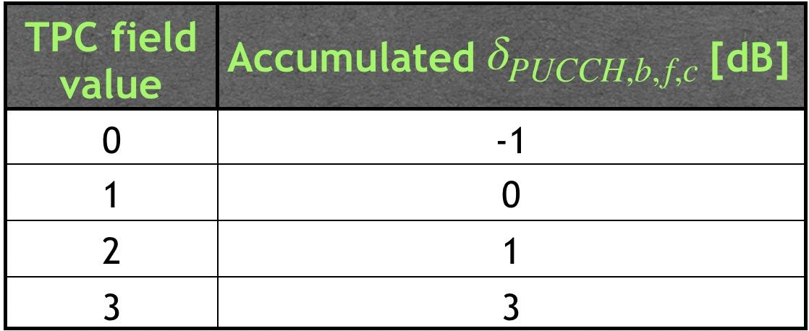

- **Note5** - PDSCH-to-HARQ_feedback timing indicator: This field informs the UE about the timing of HARQ feedback (in slots) relative to PDSCH reception. This field values maps to {1, 2, 3, 4, 5, 6, 7, 8}. For example, if the UE detects a DCI format 1_0 scheduling a PDSCH reception ending in slot *n*, the UE provides corresponding HARQ-ACK information in a PUCCH transmission within slot *n*+*k*, where *k* is a number of slots as indicated by this field.

- **Note6** - UL/SUL indicator: If the value of the "Random Access Preamble index" is not all zeros and if the UE is configured with *supplementaryUplink*, this field indicates whether PRACH should be sent on Normal uplink or Supplementary uplink; otherwise, this field is reserved.

- **Note7** - SS/PBCH index: If the value of the "Random Access Preamble index" is not all zeros, this field indicates the SS/PBCH that shall be used to determine the RACH occasion for the PRACH transmission; otherwise, this field is reserved.

- **Note8** - PRACH Mask index: If the value of the "Random Access Preamble index" is not all zeros, this field indicates the RACH occasion associated with the SS/PBCH indicated by "SS/PBCH index" for the PRACH transmission; otherwise, this field is reserved.

**DCI Format 1_1**

DCI format 1_1 is used for allocating downlink resources for PDSCH. As explained before, this is a non-fallback DCI format. Unlike DCI format 1_0, this DCI format can only be addressed to C-RNTI, CS-RNTI or MCS-C-RNTI.

The following table summarizes the information transmitted by means of the DCI format 1_1 with CRC scrambled by C-RNTI or CS- RNTI or MCS-C-RNTI.

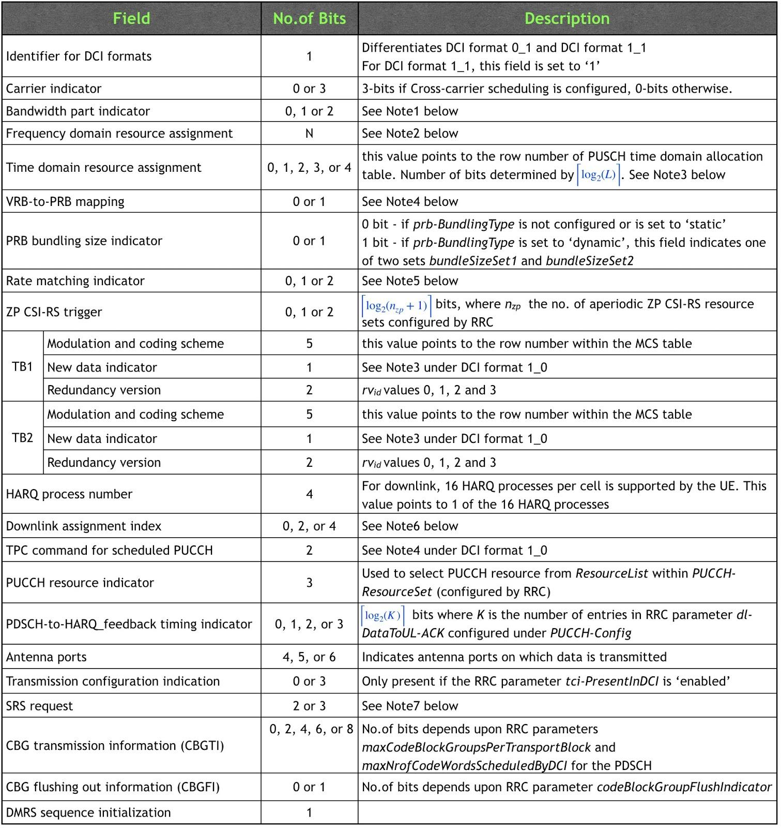

- **Note1** - Bandwidth part indicator: Indicates the BWP in which the current frequency resources (provided via this DCI) are located. This field takes 0, 1 or 2 bits depending upon the number of DL BWPs configured by RRC, excluding the initial DL BWP. If a UE does not support active BWP change via DCI, the UE ignores this bit field.

- **Note2** - Frequency domain resource assignment: Number of bits depends up on the size of the downlink BWP as well as the type of resource allocation configured by RRC. The resource allocation type is configured by RRC via *resourceAllocation* within *PDSCH-config* IE. *resourceAllocation* can be set to *resourceAllocationType0, resourceAllocationType1, dynamicSwitch* (dynamic switching between Type0 and Type1).

- **Note3**: Through “Time domain resource assignment” field in the DCI, the network indicates the entry to choose from PDSCH time domain allocation table. The table is either the default PDSCH time domain allocation according to table 6.1.2.1.1-2 from 38.214 or configured by RRC using IE *PDSCH-TimeDomainResourceAllocationList* which is configured in *PDSCH-Config*. The bitwidth for this field is determined as Ceiling(log base 2 (*L*)) bits, where *L* is the number of entries in the higher layer parameter *pdsch-TimeDomainAllocationList* if the higher layer parameter is configured; otherwise *L* is the number of entries in the default table*.*

- **Note4** - VRB-to-PRB mapping: This field is not present if only resource allocation Type0 is configured or if interleaved VRB-to-PRB mapping is not configured. If present, this field can take 1 bit but is only applicable for resource allocation type1; value ‘0’ indicates non-interleaved and value ‘1’ indicates Interleaved.

- **Note5** - Rate matching indicator: 0, 1, or 2 bits according to higher layer parameters *rateMatchPatternGroup1* and *rateMatchPatternGroup2*, where the MSB is used to indicate *rateMatchPatternGroup1* and the LSB is used to indicate *rateMatchPatternGroup2* when there are two groups.

- **Note6** - Downlink assignment index: This field is only present in case of dynamic HARQ codebook. If present, it takes 4 bits if more than one serving cell are configured in the downlink, else, 2 bits.

- **Note7** – SRS request: Used for triggering aperiodic SRS resource sets. 2 bits are required for this purpose. When *supplementaryUplink* is configured, additional bit (first bit of 3 bits) is required for non-SUL or SUL indication.

**DCI Format 2_0**

DCI format 2_0 is used for the notification of slot format information. In other words, DCI format 2_0 is used to dynamically change the slot format. DCI format 2_0 whose CRC scrambled by SFI-RNTI carries the following information.

*Slot format indicator 1, Slot format indicator 2,* ..., *Slot format indicator N*.

The size of DCI format 2_0 is configurable by RRC layer up to 128 bits. *positionInDCI* indicatesthe (starting) position (bit) of the *slotFormatCombinationId* (SFI-Index) for this serving cell (*servingCellId*) within the DCI payload.

**DCI Format 2_1**

The gNB may preempt an ongoing PDSCH transmission to one UE with a latency-critical transmission to another UE. The gNB can configure UEs to monitor interrupted transmission indications using INT-RNTI on a PDCCH. If a UE receives the interrupted transmission indication, the UE may assume that no useful information to that UE was carried by the resource elements included in the indication, even if some of those resource elements were already scheduled to this UE.

DCI format 2_1 is used for notifying the PRB(s) and OFDM symbol(s) where UE may assume no transmission is intended for the UE.

The following information is transmitted by means of the DCI format 2_1 with CRC scrambled by INT-RNTI.

*Pre-emption indication 1, Pre-emption indication 2, ..., Pre-emption indication N*.

The size of DCI format 2_1 (upto 126 bits) is configurable by RRC layer using *dci-PayloadSize* within *DownlinkPreemption* IE. Each pre-emption indication is 14 bits.

**DCI Format 2_2**

DCI format 2_2 is used for the transmission of TPC commands for PUCCH and PUSCH.

The following information is transmitted by means of the DCI format 2_2 with CRC scrambled by TPC-PUSCH-RNTI or TPC-PUCCH-RNTI:

*block number 1, block number 2,..., block number N*

The parameter *tpc-PUSCH* or *tpc-PUCCH* provided by RRC determines the index to the block number for an uplink of a cell.

**DCI Format 2_3**

DCI format 2_3 is used for the transmission of a group of TPC commands for SRS transmissions by one or more UEs. Along with a TPC command, an **SRS request** may also be transmitted within DCI.

The following information is transmitted by means of the DCI format 2_3 with CRC scrambled by TPC-SRS-RNTI:

*block number 1, block number 2,.., block number N*

For a specific UE, the parameter *startingBitOfFormat2-3* provided by RRC configuration within *SRS-TPC-CommandConfig* indicates the starting bit position of a block within the group DCI with SRS request fields (optional) and TPC commands.

DCI format 2_3 is applicable for uplink carrier(s) of serving cells where a UE is not configured for PUSCH and PUCCH transmissions or for uplink carrier(s) of a serving cell where *srs-PowerControlAdjustmentStates* indicates a separate power control adjustment state between SRS transmissions and PUSCH transmissions.

**DCI**

The main purpose of DCI (Downlink Control Information) is the same as DCI in LTE(I strongly recommend you to read [LTE DCI page](https://www.sharetechnote.com/html/DCI.html) first if you are not so familiar with what the DCI does). That is, it is a special set of information which schedules downlink data channel (e.g, PDSCH) or uplink data channel (e.g, PUSCH).

Followings are the list of DCI types and its contents defined in 38.212 - 7.3 Downlink control information.

< 38.212 - Table 7.3.1-1: DCI formats >

|  |  |
| --- | --- |
| DCI Format | Usage |
| [Format 0_0](https://www.sharetechnote.com/html/5G/5G_DCI.html#Format_0_0) | Scheduling of PUSCH in one cell |
| [Format 0_1](https://www.sharetechnote.com/html/5G/5G_DCI.html#Format_0_1) | Scheduling of PUSCH in one cell  [DCI format 0_1 with CRC scrambled by C-RNTI](https://www.sharetechnote.com/html/5G/5G_DCI.html#DCI_format_0_1_C_RNTI)  [DCI format 0_1 with CRC scrambled by CS-RNTI](https://www.sharetechnote.com/html/5G/5G_DCI.html#DCI_format_0_1_CS_RNTI) |
| [Format 1_0](https://www.sharetechnote.com/html/5G/5G_DCI.html#Format_1_0) | Scheduling of PDSCH in one cell  [DCI format 1_0 with CRC scrambled by C-RNTI](https://www.sharetechnote.com/html/5G/5G_DCI.html#DCI_format_1_0_C_RNTI)  [DCI format 1_0 with CRC scrambled by C-RNTI for PDCCH Order](https://www.sharetechnote.com/html/5G/5G_DCI.html#DCI_format_1_0_C_RNTI_PDCCH_Order)  [DCI format 1_0 with CRC scrambled by RA-RNTI](https://www.sharetechnote.com/html/5G/5G_DCI.html#DCI_format_1_0_RA_RNTI)  [DCI format 1_0 with CRC scrambled by TC-RNTI](https://www.sharetechnote.com/html/5G/5G_DCI.html#DCI_format_1_0_TC_RNTI)  [DCI format 1_0 with CRC scrambled by SI-RNTI](https://www.sharetechnote.com/html/5G/5G_DCI.html#DCI_format_1_0_SI_RNTI)  [DCI format 1_0 with CRC scrambled by P-RNTI](https://www.sharetechnote.com/html/5G/5G_DCI.html#DCI_format_1_0_P_RNTI) |
| [Format 1_1](https://www.sharetechnote.com/html/5G/5G_DCI.html#Format_1_1) | Scheduling of PDSCH in one cell |
| [Format 2_0](https://www.sharetechnote.com/html/5G/5G_DCI.html#Format_2_0) | Notifying a group of UEs of the slot format |
| [Format 2_1](https://www.sharetechnote.com/html/5G/5G_DCI.html#Format_2_1) | Notifying a group of UEs of the PRB(s) and OFDM symbol(s) where UE may assume no transmission is intended for the UE |
| [Format 2_2](https://www.sharetechnote.com/html/5G/5G_DCI.html#Format_2_2) | Transmission of TPC commands for PUCCH and PUSCH |
| [Format 2_3](https://www.sharetechnote.com/html/5G/5G_DCI.html#Format_2_3) | Transmission of a group of TPC commands for SRS transmissions by one or more UEs |
| [Format 2_4](https://www.sharetechnote.com/html/5G/5G_DCI.html#Format_2_4) | Notifying the PRB(s) and OFDM symbol(s) where UE cancels the corresponding UL transmission from the UE |
| [Format 2_5](https://www.sharetechnote.com/html/5G/5G_DCI.html#Format_2_5) | Notifying the availability of soft resources |
| [Format 2_6](https://www.sharetechnote.com/html/5G/5G_DCI.html#Format_2_6) | Notifying the power saving information outside DRX Active Time for one or more UEs |
| Format 3_0 | Scheduling of NR sidelink in one cell |
| Format 3_1 | Scheduling of LTE sidelink in one cell |

NOTE : The contents of the table shown here is based on 38.212. This specification is very dry. As any other 3GPP spcecification, it just describes 'what should be done' and does not describe anything on the background story. To get any further technical background, you need to follow through a lot of TDocs. However, unless you are a firmware or DSP engineering implementing the physical channel, it will be very difficult to keep track of all the TDocs. One trick that I would recommend is to go through several latest TDocs not far away from TS (Technical Specification) because those TDocs usually have the summary of past stories and more detailed design concept. I put several TDocs under Reference section that might help you to get some background stories.

Once a DCI data is constructed, it goes to the channel coding process and transmitted over PDCCH. This process is described in followng page.

* [PDCCH Transport Process](https://www.sharetechnote.com/html/5G/5G_PDCCH.html#PDCCH_Transport_Process)

**Format 0_0**

This is used for the scheduling of PUSCH in one cell.

|  |  |  |
| --- | --- | --- |
| Field (Item) | Bits | Reference |
| Identifier for DCI formats | 1 |  |
| Frequency domain resource assignment | 4 | Variable with UL [BWP](https://www.sharetechnote.com/html/5G/5G_CarrrierBandwidthPart.html) N_RB.  Indicate PRB location within the BWP.  The number of bits and the value is determined as described [here](https://www.sharetechnote.com/html/5G/5G_DCI.html#Format_0_0_Frequency_domain_resource_assignment). |
| Time domain resource assignment | X | Carries the row index of the items in [pusch_allocationList in RRC](https://www.sharetechnote.com/html/5G/5G_PUSCH.html#PUSCH_CONFIG_pusch_AllocationList) |
| Frequency Hopping Flag | 1 |  |
| Modulation and coding scheme | 5 | 38.214 - 6.1.4 (See [this table](https://www.sharetechnote.com/html/5G/5G_DCI.html#38_214_Table_6_1_4_1)) |
| New data indicator | 1 |  |
| Redundancy version | 2 | 0,1,2,3 |
| HARQ process number | 4 |  |
| TPC command for scheduled PUSCH | 2 | [38.213 - Table 7.1.1-1](https://www.sharetechnote.com/html/5G/5G_DCI.html#Format_0_0_38_213_Table_7_1_1_1) |
| UL/SUL indicator | 0 or 1 | 0 bit : SUL not figured  1 bit : SUL configured |

< Frequency domain resource assignment >

The number of bits(bit length) for this field is determined by following formula

  
   
The meaning of varies depending on the search space where DCI_0_0 is transmitted.

* + When stransmitted in common search space,
  + it indicates the size of the Initial Bandwidth PartWhen stransmitted in UE specific search space and meets following criteria

the total number of different DCI sizes monitored per slot <= 4  
the total number of different DCI sizes with C-RNTI monitored per slot <= 3  
it indicates the size of the Active Bandwidth Part

The value of this field is determined as follows.

* Case 1 : PUSCH hopping = True and Resource allocation type 1
  +  MSB bits are used to indicate the frequency offset
    - = 1 if Frequency-hopping-offsets-set contains two offset values
    - = 2 if Frequency-hopping-offsets-set contains four offset values
    - Remaining Bits indicates [PUSCH RIV](https://www.sharetechnote.com/html/5G/5G_ResourceAllocationType.html#Uplink_RIV)
* Case 2 : PUSCH hopping = False and Resource allocation type 1
  + the whole bits of this field indicates [PUSCH RIV](https://www.sharetechnote.com/html/5G/5G_ResourceAllocationType.html#Uplink_RIV)

< 38.214 v15.1 - Table 6.1.4.1-1: MCS index table for PUSCH with transform precoding and 64QAM >

|  |  |  |  |
| --- | --- | --- | --- |
| MCS Index  I_MCS | Modulation Order  Qm | Target code Rate  R x 1024 | Spectral  efficiency |
| 0 | q | 240/ q | 0.2344 |
| 1 | q | 314/ q | 0.3066 |
| 2 | 2 | 193 | 0.377 |
| 3 | 2 | 251 | 0.4902 |
| 4 | 2 | 308 | 0.6016 |
| 5 | 2 | 379 | 0.7402 |
| 6 | 2 | 449 | 0.877 |
| 7 | 2 | 526 | 1.0273 |
| 8 | 2 | 602 | 1.1758 |
| 9 | 2 | 679 | 1.3262 |
| 10 | 4 | 340 | 1.3281 |
| 11 | 4 | 378 | 1.4766 |
| 12 | 4 | 434 | 1.6953 |
| 13 | 4 | 490 | 1.9141 |
| 14 | 4 | 553 | 2.1602 |
| 15 | 4 | 616 | 2.4063 |
| 16 | 4 | 658 | 2.5703 |
| 17 | 6 | 466 | 2.7305 |
| 18 | 6 | 517 | 3.0293 |
| 19 | 6 | 567 | 3.3223 |
| 20 | 6 | 616 | 3.6094 |
| 21 | 6 | 666 | 3.9023 |
| 22 | 6 | 719 | 4.2129 |
| 23 | 6 | 772 | 4.5234 |
| 24 | 6 | 822 | 4.8164 |
| 25 | 6 | 873 | 5.1152 |
| 26 | 6 | 910 | 5.332 |
| 27 | 6 | 948 | 5.5547 |
| 28 | 1 | reserved | |
| 29 | 2 | reserved | |
| 30 | 4 | reserved | |
| 31 | 6 | reserved | |

< 38.213 v2.0.0 - Table 7.1.1-1: Mapping of TPC Command Field in DCI format 0_0, DCI format 0_1, or DCI format 2_2, or DCI format 2_3 having CRC parity bits scrambled by TPC-PUSCH-RNTI or TPC-SRS-RNTI, to absolute and accumulated d_PUSCH,c values >

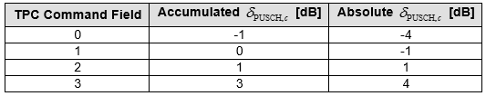

**Format 0_1**

This is used for the scheduling of PUSCH in one cell.

< DCI format 0_1 with CRC scrambled by C-RNTI >

|  |  |  |
| --- | --- | --- |
| Field (Item) | Bits | Reference |
| Identifier for DCI formats | 1 |  |
| Carrier indicator | 0 or 3 |  |
| UL/SUL Indicator | 0,1 | 0 - bit for UE not configured with SUL in the cell  1 - bit for UEs configured with SUL in the cell |
| Bandwidth part indicator | 0,1,2 | Determined by [BandwidthPart-Config](https://www.sharetechnote.com/html/5G/5G_CarrrierBandwidthPart.html#RRC_Parameters_BandwidthPart_Configuration) in higher layer message and [38.212 - Table 7.3.1.1.2-1](https://www.sharetechnote.com/html/5G/5G_DCI.html#Format_0_1_38_212_Table_7_3_1_1_2_1) |
| Frequency domain resource assignment | Variable | [Variable with Resource Allocation Type](https://www.sharetechnote.com/html/5G/5G_DCI.html#Format_0_1_Frequency_domain_resource_assignment) |
| Time domain resource assignment | 4 | Carries the row index of the items in [pusch_allocationList in RRC](https://www.sharetechnote.com/html/5G/5G_PUSCH.html#PUSCH_CONFIG_pusch_AllocationList)  Number of Bit Length is determined by log(I,2), where I is the number of elements in [pusch_allocationList in RRC](https://www.sharetechnote.com/html/5G/5G_PUSCH.html#PUSCH_CONFIG_pusch_AllocationList) |
| Frequency Hopping Flag | 0,1 |  |
| Modulation and coding scheme | 5 | 38.214 - 6.1.4 (See [this table](https://www.sharetechnote.com/html/5G/5G_DCI.html#38_214_Table_6_1_4_1)) |
| New data indicator | 1 |  |
| Redundancy version | 2 | 0,1,2,3 |
| HARQ process number | 4 |  |
| 1st Downlink assignment index | 1,2 |  |
| 2nd Downlink assignment index | 0,2 |  |
| TPC command for scheduled PUSCH | 2 |  |
| SRS resource indicator | Variable | [Determined by RRC Parameter SRS-SetUse](https://www.sharetechnote.com/html/5G/5G_DCI.html#Format_0_1_SRS_resource_indicator) |
| Precoding information and number of layers  (TPMI) | 0,2,3,4,5,6 | Determined by [ulTxConfig, Number of Antenna ports, PUSCH-tp, ULmaxRank](https://www.sharetechnote.com/html/5G/5G_DCI.html#Format_0_1_PrecodingInformation) |
| Antenna ports | 2,3,4,5 | Determined by [PUSCH-tp, DL-DMRS-config-type, DL-DMRS-config-max-len, Rank](https://www.sharetechnote.com/html/5G/5G_DCI.html#Format_0_1_Antenna_ports) |
| SRS request | 2 | [Table 7.3.1.1.2-24](https://www.sharetechnote.com/html/5G/5G_DCI.html#38_212_Table_7_3_1_1_2_24) |
| CSI request | 0,1,2,3,4,5,6 | Determined by ReportTriggerSize in RRC message.  See [Configure Aperiodic Trigger](https://www.sharetechnote.com/html/5G/5G_CSI_Report.html#How_to_configure_Aperiodic_Report_Trigger) section for the details. |
| CBG transmission information | 0,2,4,6,8 | Determined by maxCodeBlockGroupPerTransportblock in RRC message |
| PTRS - DMRS Association | 0,2 | Determined by [UL-PTRS-present, PUSCH-tp](https://www.sharetechnote.com/html/5G/5G_DCI.html#Format_0_1_PTRS_DMRS_Association) in RRC Message |
| beta_offsetr Indicator | 0,2 | 0 - if uci-on-PUSCH.dynamic = Not Configured  2 - otherwise, see Table 7.3.1.1.2-27 |
| DMRS Sequence Initialization | 0,1 | 0 - if PUSCH-tp=Disabled  1 - if PUSCH-tp=Enabled |
| UL-SCH Indicator | 1 | 0 - UL-SCH shall not be transmitted on the PUSCH  1 - UL-SCH shall be transmitted on the PUSCH |

< DCI format 0_1 with CRC scrambled by CS-RNTI >

|  |  |  |
| --- | --- | --- |
| Field (Item) | Bits | Reference |
| Identifier for DCI formats | 1 |  |
| Carrier indicator | 0 or 3 |  |
| DFI Flag | 0 or 1 | 1 bit when [cg-Retransmission](https://www.sharetechnote.com/html/5G/5G_ConfiguredScheduling.html#cg_RetransmissionTimer)Timer is configured   * value 0 : activating or releasing type 2 CG transmission * value 1 : CG-DFI |
| HARQ-ACK bitmap | 16 | HARQ process indices are mapped in ascending order from MSB to LSB of the bitmap |
| TPC command for scheduled PUSCH | 2 |  |
| All the remaining bits |  | set to 0 |

< 38.212 v15.3.0 - Table 7.3.1.1.2-1: Bandwidth part indicator >

|  |  |  |
| --- | --- | --- |
| Value of BWP indicator field | | Bandwidth part |
| 1 bit | 2 bits |
| 0 | 0 | First bandwidth part configured by higher layers |
| 1 | 1 | Second bandwidth part configured by higher layers |
|  | 10 | Third bandwidth part configured by higher layers |
|  | 11 | Fourth bandwidth part configured by higher layers |

< Frequency domain resource assignment >

The bit length of this field is determined as follows.

|  |  |
| --- | --- |
| Resource Allocation Type | Mumber of Bits |
| [Resource Allocation Type 0](https://www.sharetechnote.com/html/5G/5G_ResourceAllocationType.html#Allocation_Type_0) only | , P is defined in [38.214 Table 6.1.2.2.1-1](https://www.sharetechnote.com/html/5G/5G_DCI.html#Format_0_1_38_214_Table_6_1_2_2_1_1) |
| [Resource Allocation Type 1](https://www.sharetechnote.com/html/5G/5G_ResourceAllocationType.html#Allocation_Type_1) only |  |
| [Resource Allocation Type 0 and Type 1](https://www.sharetechnote.com/html/5G/5G_ResourceAllocationType.html#Dynamic_Switch) | Bit Length :    MSB Indicates Resource Allocation Type  0 : Resource Allocation Type 0  1 : Resource Allocation Type 1 |

The value of this field is determined as follows :

* Resource Allocation Type 0 only : Bitmap determined as described [here](https://www.sharetechnote.com/html/5G/5G_ResourceAllocationType.html#Allocation_Type_0).
* Resource Allocation Type 1 only : Determined depending on PUSCH Hopping field as follows
  + Case 1 : PUSCH hopping = True
    -  MSB bits are used to indicate the frequency offset
      * = 1 if Frequency-hopping-offsets-set contains two offset values
      * = 2 if Frequency-hopping-offsets-set contains four offset values
      * Remaining Bits indicates [PUSCH RIV](https://www.sharetechnote.com/html/5G/5G_ResourceAllocationType.html#Uplink_RIV)
  + Case 2 : PUSCH hopping = False
  + the whole bits of this field indicates [PUSCH RIV](https://www.sharetechnote.com/html/5G/5G_ResourceAllocationType.html#Uplink_RIV)

< 38.214-v15.3.0 Table 6.1.2.2.1-1: Nominal RBG size P >

|  |  |  |
| --- | --- | --- |
| Carrier Bandwidth Part Size | Configuration 1 | Configuration 2 |
| 1-36 | 2 | 4 |
| 37-72 | 4 | 8 |
| 73-144 | 8 | 16 |
| 145-275 | 16 | 16 |

NOTE : Which RBG(Resource Block Group) size to be used is determined by PUSCH-Config.rbg-Size in RRC message from gNB

< SRS resource indicator >

|  |  |  |
| --- | --- | --- |
| SRS-ResourceSet.usage | Bit Length of SRS Resource Indicator | |
| CodeBook |  | N_SRS is the number of configured SRS resources in the SRS resource set associated with "usage". |
| NonCodeBook |  |  |

< 38.212-Table 7.3.1.1.2-24: SRS request >

|  |  |
| --- | --- |
| Value of SRS request field | Triggered aperiodic SRS resource set(s) |
| 00 | No aperiodic SRS resource set triggered |
| 01 | SRS resource set(s) configured with higher layer parameter aperiodicSRS-ResourceTrigger set to 1 |
| 10 | SRS resource set(s) configured with higher layer parameter aperiodicSRS-ResourceTrigger set to 2 |
| 11 | SRS resource set(s) configured with higher layer parameter aperiodicSRS-ResourceTrigger set to 3 |

< Precoding information and number of layers >

|  |  |  |  |  |  |  |
| --- | --- | --- | --- | --- | --- | --- |
| txConfig(UL) | Antenna | PUSCH-tp | maxRank | CodebookSubset | Bit Length | Table in 38.212 |
| NonCodeBook |  |  |  |  | 0 |  |
| CodeBook | 4 ports | Disabled | 2 or 3 or 4 |  | 4 or 5 or 6 | 7.3.1.1.2-2 |
| CodeBook | 4 ports | Disabled |  |  | 2 or 4 or 5 | 7.3.1.1.2-3 |
| Enabled | 1 |  |
| CodeBook | 2 ports |  | 2 |  | 3 or 4 | 7.3.1.1.2-4 |
| CodeBook | 2 ports |  | 1 |  | 2 or 3 | 7.3.1.1.2-5 |

NOTE : PUSCH-tp indicates PUSCH Transform Precoding. Refer to [Transform Precoding section](https://www.sharetechnote.com/html/5G/5G_Waveform.html#Transform_Precoding) in Waveform Page if you want to know what this is.

NOTE : txConfig, PUSCH-tp, maxRank, codebook Subset are specified by [PUSCH-Config](https://www.sharetechnote.com/html/5G/5G_PUSCH.html#RRC_Parameters) in RRC.

< Antenna ports >

|  |  |  |  |  |  |
| --- | --- | --- | --- | --- | --- |
| PUSCH-tp | DMRS-config-type | DMRS-config-max-len | Rank | Bit Lenth | Table in 38.212 |
| Enabled | 1 | 1 |  | 2 | 7.3.1.1.2-6 |
| 1 | 2 |  | 4 | 7.3.1.1.2-7 |
| Disabled | 1 | 1 | 1 | 3 | 7.3.1.1.2-8 |
| 1 | 1 | 2 | 3 | 7.3.1.1.2-9 |
| 1 | 1 | 3 | 3 | 7.3.1.1.2-10 |
| 1 | 1 | 4 | 3 | 7.3.1.1.2-11 |
| Disabled | 1 | 2 | 1 | 4 | 7.3.1.1.2-12 |
| 1 | 2 | 2 | 4 | 7.3.1.1.2-13 |
| 1 | 2 | 3 | 4 | 7.3.1.1.2-14 |
| 1 | 2 | 4 | 4 | 7.3.1.1.2-15 |
| Disabled | 2 | 1 | 1 | 4 | 7.3.1.1.2-16 |
| 2 | 1 | 2 | 4 | 7.3.1.1.2-17 |
| 2 | 1 | 3 | 4 | 7.3.1.1.2-18 |
| 2 | 1 | 4 | 4 | 7.3.1.1.2-19 |
| Disabled | 2 | 2 | 1 | 5 | 7.3.1.1.2-20 |
| 2 | 2 | 2 | 5 | 7.3.1.1.2-21 |
| 2 | 2 | 3 | 5 | 7.3.1.1.2-22 |
| 2 | 2 | 4 | 5 | 7.3.1.1.2-23 |

NOTE : PUSCH-tp indicates PUSCH Transform Precoding. Refer to [Transform Precoding section](https://www.sharetechnote.com/html/5G/5G_Waveform.html#Transform_Precoding) in Waveform Page if you

< PTRS - DMRS Association >

|  |  |  |  |  |  |
| --- | --- | --- | --- | --- | --- |
| UL-PTRS-present | PUSCH-tp | UL PTRS port | UL-PTRS-ports | Bit Length | Table in 38.212 |
| OFF | Disabled |  |  | 0 | N/A |
| ON | Enabled |  |  | 0 | N/A |
| ON | Disabled |  |  | 0 | N/A |
| Otherwise | | 0 | 1 | 2 | 7.3.1.1.2-25 |
| 0 | 2 | 2 | 7.3.1.1.2-26 |
| 1 | 2 | 2 | 7.3.1.1.2-26 |

**Format 1_0**

This is used for the scheduling of PDSCH in one cell.

< DCI format 1_0 with CRC scrambled by C-RNTI >

|  |  |  |
| --- | --- | --- |
| Field (Item) | Bits | Reference |
| Identifier for DCI formats | 1 | Always set to 1, meaning this is for DL |
| Frequency domain resource assignment | Variable | Variable with DL [BWP](https://www.sharetechnote.com/html/5G/5G_CarrrierBandwidthPart.html) N_RB |
| Time domain resource assignment | 4 | Carries the row index of the items in [pdsch_allocationList in RRC](https://www.sharetechnote.com/html/5G/5G_PDSCH.html#PDSCH_Config_pdsch_AllocationList) |
| VRB-to-PRB mapping | 1 | According to 38.212 Table 7.3.1.1.2-33  0 : Non-Interleaved  1 : Inverleaved |
| Modulation and coding scheme | 5 | [38.214 - Table 5.1.3.1-1: MCS index table 1 for PDSCH](https://www.sharetechnote.com/html/5G/5G_MCS_TBS_CodeRate.html#38_214_Table_5_1_3_1_1)  [38.214 - Table 5.1.3.1-2: MCS index table 2 for PDSCH](https://www.sharetechnote.com/html/5G/5G_MCS_TBS_CodeRate.html#38_214_Table_5_1_3_1_2) |
| New data indicator | 1 |  |
| Redundancy version | 2 |  |
| HARQ process number | 4 |  |
| Downlink assignment index | 2 |  |
| TPC command for scheduled PUCCH | 2 |  |
| PUCCH resource indicator | 3 | See [here](https://www.sharetechnote.com/html/5G/5G_PUCCH.html#How_does_UE_figure_out_which_resource_to_apply) , [here](https://www.sharetechnote.com/html/5G/5G_PUCCH.html#How_the_PUCCH_Resource_table_is_defined) |
| PDSCH-to-HARQ_feedback timing indicator | 3 | maps to k1={1,2,3,4,5,6,7,8} - NOTE 2 |

NOTE 1 : The meaning of varies depending on the search space where DCI_1_0 is transmitted.

* When stransmitted in common search space,
* it indicates the size of the Initial Bandwidth Part  
  When stransmitted in UE specific search space and meets following criteria

the total number of different DCI sizes monitored per slot <= 4  
the total number of different DCI sizes with C-RNTI monitored per slot <= 3  
it indicates the size of the Active Bandwidth Part

NOTE 2 : In case of DCI 1_1, this field indicates the index value of dl-DataToUL-ACK, dl-DataToUL-ACK-r16 configured in RRC, but this field in DCI 1_0 refers to the index of pre-defined set {1,2,3,4,5,6,7,8}. This is based on following specification.

38.213-9.2.3  
For DCI format 1_0, the PDSCH-to-HARQ_feedback timing indicator field values map to {1, 2, 3, 4, 5, 6, 7, 8}. For a DCI format, other than DCI format 1_0, scheduling a PDSCH reception or a SPS PDSCH release, the PDSCH-to HARQ_feedback timing indicator field values, if present, map to values for a set of number of slots provided by dl- DataToUL-ACK, dl-DataToUL-ACK-r16, or dl-DataToUL-ACKForDCIFormat1_2

< DCI format 1_0 with CRC scrambled by C-RNTI for PDCCH Order>

|  |  |  |
| --- | --- | --- |
| Field (Item) | Bits | Reference |
| Identifier for DCI formats | 1 | Always set to 1, meaning this is for DL |
| Frequency domain resource assignment | Variable | All Ones |
| Random Access Preamble index | 6 | 6 bits according to ra-PreambleIndex |
| UL/SUL indicator | 1 | NOTE 1 |
| SS/PBCH index | 6 | NOTE 2 |
| PRACH Mask index | 4 | NOTE 3 |
| Reserved bits | 12 or 10 | NOTE 4 |

NOTE 1 : If the value of the "Random Access Preamble index" is not all zeros and if the UE is configured with supplementaryUplink in ServingCellConfig in the cell, this field indicates which UL carrier in the cell to transmit the PRACH according to Table 7.3.1.1.1-1( 0 = Non Supplimentary Uplink, 1 = Supplementary Uplink); otherwise, this field is reserved

NOTE 2 : If the value of the "Random Access Preamble index" is not all zeros, this field indicates the SS/PBCH that shall be used to determine the RACH occasion for the PRACH transmission; otherwise, this field is reserved.

NOTE 3 : If the value of the "Random Access Preamble index" is not all zeros, this field indicates the RACH occasion associated with the SS/PBCH indicated by "SS/PBCH index" for the PRACH transmission, according to Clause 5.1.1 of 38.321; otherwise, this field is reserved

NOTE 4 : 12 bits for operation in a cell with shared spectrum channel access; otherwise 10 bits

TB Scaling is special parameters affecting the determination of Transport Block Size. This factor is multiplied to the result of the [calculated Ninfo value](https://www.sharetechnote.com/html/5G/5G_MCS_TBS_CodeRate.html#PDSH_Calculate_N_info).

< 38.214 - Table 5.1.3.2-2: Scaling factor of Ninfo for P-RNTI, RA-RNTI and MSGB-RNTI >

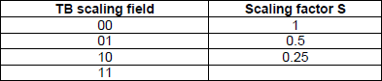

< DCI format 1_0 with CRC scrambled by TC-RNTI >

: This is used to schedule [Contention Resolution (Msg4) in RACH Procedure](https://www.sharetechnote.com/html/5G/5G_RACH.html#InitialAttach_Step_E)

|  |  |  |
| --- | --- | --- |
| Field (Item) | Bits | Reference |
| Identifier for DCI formats | 1 | Always set to 1, meaning this is for DL |
| Frequency domain resource assignment | Variable | Variable with DL [BWP](https://www.sharetechnote.com/html/5G/5G_CarrrierBandwidthPart.html) N_RB    indicates the size of CORESET 0 |
| Time domain resource assignment | 4 | Carries the row index of the items in [pdsch_allocationList in RRC](https://www.sharetechnote.com/html/5G/5G_PDSCH.html#PDSCH_Config_pdsch_AllocationList) |
| VRB-to-PRB mapping | 1 | According to 38.212 Table 7.3.1.1.2-33  0 : Non-Interleaved  1 : Inverleaved |
| Modulation and coding scheme | 5 | [38.214 - Table 5.1.3.1-1: MCS index table 1 for PDSCH](https://www.sharetechnote.com/html/5G/5G_MCS_TBS_CodeRate.html#38_214_Table_5_1_3_1_1)  [38.214 - Table 5.1.3.1-2: MCS index table 2 for PDSCH](https://www.sharetechnote.com/html/5G/5G_MCS_TBS_CodeRate.html#38_214_Table_5_1_3_1_2) |
| New data indicator | 1 |  |
| Redundancy version | 2 |  |
| HARQ process number | 4 |  |
| Downlink assignment index | 2 | Reserved |
| TPC command for scheduled PUCCH | 2 |  |
| PUCCH resource indicator | 3 | See [here](https://www.sharetechnote.com/html/5G/5G_PUCCH.html#How_does_UE_figure_out_which_resource_to_apply) , [here](https://www.sharetechnote.com/html/5G/5G_PUCCH.html#How_the_PUCCH_Resource_table_is_defined) |
| PDSCH-to-HARQ_feedback timing indicator | 3 | [Row number(index) of K1](https://www.sharetechnote.com/html/5G/5G_ResourceAllocation.html#PDSCH_Ack_Nack_Timing) |

The meaning of varies depending on the search space where DCI_1_0 is transmitted.

* When stransmitted in common search space in CORESET 0 ,
* it indicates the size of the Initial Bandwidth Part  
  When stransmitted in UE specific search space and meets following criteria

the total number of different DCI sizes monitored per slot <= 4  
the total number of different DCI sizes with C-RNTI monitored per slot <= 3

it indicates the size of the Active Bandwidth Part

< DCI format 1_0 with CRC scrambled by SI-RNTI >

: This is used to schedule [SIB1 and other SIB](https://www.sharetechnote.com/html/5G/5G_Mib_Sib.html#SystemInformationBlockType1) messages

|  |  |  |
| --- | --- | --- |
| Field (Item) | Bits | Reference |
| Frequency domain resource assignment | Variable | Variable with DL [BWP](https://www.sharetechnote.com/html/5G/5G_CarrrierBandwidthPart.html) N_RB    indicates the size of CORESET 0 |
| Time domain resource assignment | 4 | Carries the row index of the items.   * In case of DCI for SIB1, this refers to a table specified in [38.214 - Table 5.1.2.1.1-1](https://www.sharetechnote.com/html/5G/5G_ApplicableTimeDomainAllocation.html#Table_5_1_2_1_1_1). ([NOTE 1](https://www.sharetechnote.com/html/5G/5G_DCI.html#DCI_1_0_SI_NOTE_1)) * In case of DCI for Other SIB, this refer to [pdsch_TimeDomainAllocation in SIB](https://www.sharetechnote.com/html/5G/5G_PDSCH.html#PDSCH_Config_pdsch_AllocationList) |
| VRB-to-PRB mapping | 1 | According to 38.212 Table 7.3.1.1.2-33  0 : Non-Interleaved  1 : Inverleaved |
| Modulation and coding scheme | 5 | [38.214 - Table 5.1.3.1-1: MCS index table 1 for PDSCH](https://www.sharetechnote.com/html/5G/5G_MCS_TBS_CodeRate.html#38_214_Table_5_1_3_1_1)  [38.214 - Table 5.1.3.1-2: MCS index table 2 for PDSCH](https://www.sharetechnote.com/html/5G/5G_MCS_TBS_CodeRate.html#38_214_Table_5_1_3_1_2) |
| Redundancy Version | 2 |  |
| System Information Indicator | 1 | 0 : SIB 1  1 : SI messages |
| Reserved | 15 | Reserved |

[NOTE 1] SIB1 DCI refer to SI-RNTI / Type0Common in [38.214 - Table 5.1.2.1.1-1](https://www.sharetechnote.com/html/5G/5G_ApplicableTimeDomainAllocation.html#Table_5_1_2_1_1_1). As you see in the table, different TimeDomainResourceAllocation table is used depending on SSB/CORESET Multiplexing Pattern as summarized in the following table.

|  |  |  |
| --- | --- | --- |
| SSB/CORESET Multiplexing Pattern | TimeDomainAllocation To Apply | 3GPP Table |
| 1 | Default A for Normal CP | [38.214-Table 5.1.2.1.1-2](https://www.sharetechnote.com/html/5G/5G_ApplicableTimeDomainAllocation.html#Table_5_1_2_1_1_2) |
| 2 | Default B | [38.214-Table 5.1.2.1.1-4](https://www.sharetechnote.com/html/5G/5G_ApplicableTimeDomainAllocation.html#Table_5_1_2_1_1_4) |
| 3 | Defualt C | [38.214-Table 5.1.2.1.1-5](https://www.sharetechnote.com/html/5G/5G_ApplicableTimeDomainAllocation.html#Table_5_1_2_1_1_5) |

< DCI format 1_0 with CRC scrambled by P-RNTI>

: This is used to schedule Paging messages

|  |  |  |
| --- | --- | --- |
| Field (Item) | Bits | Reference |
| Short Message Indicator | 2 | Refer to [38.212 - Table 7.3.1.2.1-1](https://www.sharetechnote.com/html/5G/5G_DCI.html#38_212_Table_7_3_1_2_1_1) |
| Short Messages | 8 | This field is set as reserved when 'Short Message Indicator' field is 01.  Refer to [38.331 - Table 6.5-1](https://www.sharetechnote.com/html/5G/5G_DCI.html#38_331_Table_6_5_1) |
| Frequency domain resource assignment | Variable | Variable with DL [BWP](https://www.sharetechnote.com/html/5G/5G_CarrrierBandwidthPart.html) N_RB    indicates the size of CORESET 0 |
| Time domain resource assignment | 4 | Carries the row index of the items in [pdsch_allocationList in RRC](https://www.sharetechnote.com/html/5G/5G_PDSCH.html#PDSCH_Config_pdsch_AllocationList) |
| VRB-to-PRB mapping | 1 | According to 38.212 Table 7.3.1.1.2-33  0 : Non-Interleaved  1 : Inverleaved |
| Modulation and coding scheme | 5 | [38.214 - Table 5.1.3.1-1: MCS index table 1 for PDSCH](https://www.sharetechnote.com/html/5G/5G_MCS_TBS_CodeRate.html#38_214_Table_5_1_3_1_1)  [38.214 - Table 5.1.3.1-2: MCS index table 2 for PDSCH](https://www.sharetechnote.com/html/5G/5G_MCS_TBS_CodeRate.html#38_214_Table_5_1_3_1_2) |
| TB Scaling | 2 |  |
| Reserved | 6 | Reserved |

< 38.212 - Table 7.3.1.2.1-1: Short Message indicator >

|  |  |
| --- | --- |
| Bit Field | Short Message Indicator |
| 00 | Reserved |
| 01 | Only scheduling information for Paging is present in the DCI |
| 10 | Only short message is present in the DCI |
| 11 | Both scheduling information for Paging and short message are present in the DCI |

< 38.331 - Table 6.5-1: Short messages >

|  |  |
| --- | --- |
| Bit | Short Message Indicator |
| 1 | systemInfoModification  If set to 1: indication of a BCCH modification other than SIB6, SIB7 and SIB8. |
| 2 | etwsAndCmasIndication  If set to 1: indication of an ETWS primary notification and/or an ETWS secondary notification and/or a CMAS notification |
| 3-[8] | Not used in this release of the specification, and shall be ignored by UE if received. |

**Format 1_1**

This is used for the scheduling of PDSCH in one cell.

|  |  |  |
| --- | --- | --- |
| Field (Item) | Bits | Reference |
| Carrier indicator | 0,3 |  |
| Identifier for DCI formats | 1 | Always set to 1, indicating a DL DCI format |
| Bandwidth part indicator | 0,1,2 |  |
| Frequency domain resource assignment | Variable | Variable with [Resource Allocation Type](https://www.sharetechnote.com/html/5G/5G_ResourceAllocationType.html) |
| Time domain resource assignment | 4 | Carries the row index of the items in [pdsch_allocationList in RRC](https://www.sharetechnote.com/html/5G/5G_PDSCH.html#PDSCH_Config_pdsch_AllocationList) |
| VRB-to-PRB mapping | 0,1 | 0 bit if only resource allocation type 0 is configured or if interleaved VRB-to-PRB mapping is not configured by high layers;  1 bit according to Table 7.3.1.1.2-33 otherwise, only applicable to resource allocation type 1 |
| PRB bundling size indicator | 0,1 | 0 bit if the higher layer parameter prb-BundlingType is not configured or is set to 'static'  1 bit if the higher layer parameter prb-BundlingType is set to 'dynamic' |
| Rate matching indicator | 0,1,2 | Bit size is determined by higher layer parameters rateMatchPatternGroup1 and rateMatchPatternGroup2. |
| ZP CSI-RS Trigger | 0,1,2 |  |
| Modulation and coding scheme [TB1] | 5 |  |
| New data indicator [TB1] | 1 |  |
| Redundancy version [TB1] | 2 |  |
| Modulation and coding scheme [TB2] | 5 |  |
| New data indicator [TB2] | 1 |  |
| Redundancy version [TB2] | 2 |  |
| HARQ process number | 4 |  |
| Downlink assignment index | 0,2,4 | 4 bits if more than one serving cell are configured in the DL and the higher layer parameter pdsch-HARQACK-Codebook=dynamic, where the 2 MSB bits are the counter DAI and the 2 LSB bits are the total DAI;  2 bits if only one serving cell is configured in the DL and the higher layer parameter pdsch-HARQ-ACKCodebook= dynamic, where the 2 bits are the counter DAI;  0 bits otherwise. |
| TPC command for scheduled PUCCH | 2 |  |
| PUCCH resource indicator | 3 | See [here](https://www.sharetechnote.com/html/5G/5G_PUCCH.html#How_does_UE_figure_out_which_resource_to_apply) , [here](https://www.sharetechnote.com/html/5G/5G_PUCCH.html#How_the_PUCCH_Resource_table_is_defined) |
| PDSCH-to-HARQ_feedback timing indicator | 0,1,2,3 | [Row number(index) of K1](https://www.sharetechnote.com/html/5G/5G_ResourceAllocation.html#PDSCH_Ack_Nack_Timing)  Number of bit is determined by log2(I). 'I' is the number of elements in the IE PUCCH-Config.dl-DataToUL-ACK |
| Antenna port(s) and number of layers | 4,5,6 | Determined by  dmrs Configuration Type and max Length  See this [summary table](https://www.sharetechnote.com/html/5G/5G_DCI.html#Antenna_port_and_number_of_layers) |
| Transmission configuration indication | 0,3 | 0 bit if higher layer parameter tci-PresentInDCI is not enabled;  3 bits otherwise (See [QCL page](https://www.sharetechnote.com/html/5G/5G_QCL.html)) |
| SRS request | 2 |  |
| CBG transmission information(CBGTI) | 0,2,4,6,8 |  |
| CBG flushing out information(CBGFI) | 0,1 |  |
| DMRS sequence initialization | 1 |  |

< Antenna port(s) and number of layers >

|  |  |  |  |
| --- | --- | --- | --- |
| dmrs-Type | maxLength | Bit Field Length | Table in 38.212 |
| 1 | 1 | 4 | [Table 7.3.1.2.2-1](https://www.sharetechnote.com/html/5G/5G_MIMO.html#38_212_Table_7_3_1_2_2_1) |
| 1 | 2 | 5 | [Table 7.3.1.2.2-2](https://www.sharetechnote.com/html/5G/5G_MIMO.html#38_212_Table_7_3_1_2_2_2) |
| 2 | 1 | 5 | [Table 7.3.1.2.2-3](https://www.sharetechnote.com/html/5G/5G_MIMO.html#38_212_Table_7_3_1_2_2_3) |
| 2 | 1 | 6 | [Table 7.3.1.2.2-4](https://www.sharetechnote.com/html/5G/5G_MIMO.html#38_212_Table_7_3_1_2_2_4) |

**Format 2_0**

This is used for notifying following information to UE. This DCI is scrambled by SFI_RNTI

* Slot format
* COT(Channel Occupancy Time) duration
* Available RB set
* Search space set group switching

If the higher layer parameter slotFormatCombToAddModList is configured

|  |  |  |
| --- | --- | --- |
| Field (Item) | Bits | Reference |
| Identifier for DCI formats | 1 |  |
| Slot format indicator | Variable | Bit size is determined by RRC message [here](https://www.sharetechnote.com/html/5G/5G_SlotFormatCombination.html#dci_PayloadSize) |

Slot format indicator : a Bit string indicating Slot format indicator 1, Slot format indicator 2, …, Slot format indicator N

If the higher layer parameter availableRB-SetsToAddModList is configured

|  |  |  |
| --- | --- | --- |
| Field (Item) | Bits | Reference |
| Identifier for DCI formats | 1 |  |
| Available RB set Indicator | Variable | Bit size is determined by RRC message [here](https://www.sharetechnote.com/html/5G/5G_SlotFormatCombination.html#dci_PayloadSize) |

Available RB set Indicator : a Bit string indicating Available RB set Indicator 1, Available RB set Indicator 2, …, Available RB set Indicator N

If the higher layer parameter co-DurationsPerCellToAddModList is configured

|  |  |  |
| --- | --- | --- |
| Field (Item) | Bits | Reference |
| Identifier for DCI formats | 1 |  |
| COT duration indicator | Variable | Bit size is determined by RRC message [here](https://www.sharetechnote.com/html/5G/5G_SlotFormatCombination.html#dci_PayloadSize) |

COT duration indicator : a Bit string indicating COT duration indicator 1, COT duration indicator 2, …, COT duration indicator N

**Format 2_1**

This is used for notifying the PRB(s) and OFDM symbol(s) where UE may assume no transmission is intended for the UE. This DCI is scrambled by INT-RNTI.

|  |  |  |
| --- | --- | --- |
| Field (Item) | Bits | Reference |
| Identifier for DCI formats | 1 |  |
| Pre-emption indication | Variable |  |

The size of DCI format 2_1 is configurable by higher layers up to 126 bits and each Pre-emtion indication is 14 bits(Details are in 38.213 - 11.2)

**Format 2_2**

This is used for the transmission of TPC commands for PUCCH, PUSCH. This DCI is scrambled by scrambled by TPC-PUSCH-RNTI or TPC-PUCCH-RNTI.

|  |  |  |
| --- | --- | --- |
| Field (Item) | Bits | Reference |
| Identifier for DCI formats | 1 |  |
| block number 1, block number 2,…, block number N | Variable |  |

Following fields are defined for each block

|  |  |  |
| --- | --- | --- |
| Field (Item) | Bits | Reference |
| Closed loop indicator | 0,1 |  |
| TPC Command | 2 bite |  |

**Format 2_3**

This is used for the transmission of a group of TPC commands for SRS transmissions by one or more UEs. Along with a TPC command, a SRS request may also be transmitted.

|  |  |  |
| --- | --- | --- |
| Field (Item) | Bits | Reference |
| Identifier for DCI formats | 1 |  |
| block number 1, block number 2,…, block number B | Variable |  |

Following fields are defined for each block

If the UE is configured with higher layer parameter srs-TPC-PDCCH-Group = typeA for an UL without PUCCH and

PUSCH or an UL on which the SRS power control is not tied with PUSCH power control

|  |  |  |
| --- | --- | --- |
| Field (Item) | Bits | Reference |
| SRS Request | 0,2 |  |
| TPC command number 1, TPC command number 2, ..., TPC command number N | variable |  |

If the UE is configured with higher layer parameter srs-TPC-PDCCH-Group = typeB for an UL without PUCCH and

PUSCH or an UL on which the SRS power control is not tied with PUSCH power control

|  |  |  |
| --- | --- | --- |
| Field (Item) | Bits | Reference |
| SRS Request | 0,2 |  |
| TPC command number | 2 |  |

**Format 2_4**

This DCI is used for notifying the PRB(s) and OFDM symbol(s) where UE cancels the corresponding UL transmission from the UE (Details are in 38.213-11.2A). This is scrambled by ci-RNTI.

**Format 2_5**

This DCI is used for notifying the availability of soft resources (Details in 38.473-9.3.1). This is scrambled by AI-RNTI.

**Format 2_6**

This DCI is used for notifying the power saving information outside DRX Active Time for one or more UEs. This is scrambled by PS-RNTI

Structure of DCI format 2_6 is as follows :

block number 1, block number 2,…, block number N

Structure of each block is as follows :

|  |  |  |
| --- | --- | --- |
| Field (Item) | Bits | Reference |
| Wake-up indication | 1 |  |
| SCell dormancy indication | 0,1,2,3,4,5 | * 0 bit if RRC parameter *dormancyGroupOutsideActive* is not configured   + '0' indicates to not start the drxonDurationTimer for the next long DRX cycle   + '1' indicates to start the drxonDurationTimer for the next long DRX cycle * 1, 2, 3, 4 or 5 bits bitmap determined according to higher layer parameter *dormancyGroupOutsideActive*Time, where each bit corresponds to one of the SCell group(s) configured by higher layers parameter dormancyGroupOutsideActiveTime, with MSB to LSB of the bitmap corresponding to the first to last configured SCell group. |